EuroCC2 Digital Innovation Flagship Application Form

1 Project title
A suitable name for the project

2 Project acronym
An acronym for the project

3 Keywords
Up to 5 keywords (e.g. material sciences, clinical sciences, earth sciences, astrophysics, urban planning, etc.)

4 Principal Investigator
Title
Full name
Designation
Affiliation
Email
Short biography
(2 to 3 sentences)

5 Collaborators
For each collaborator on this project provide the following information.
Title
Full name
Designation
Affiliation
Email
Short biography
(2 to 3 sentences)

Title
Full name
Designation
Affiliation
Email
Short biography
(2 to 3 sentences)

Title
Full name
Designation
Affiliation
Email
Short biography
(2 to 3 sentences)

6 Contact person for all correspondence
If different from the Principal Investigator
Title
Full name
Designation
Affiliation
Email

7 Project Summary
(Maximum 500 words)
Please provide an abstract of the proposed work for public dissemination.

8 Domain and Technical Case

8.1 Motivation and Impact
(Maximum 1 page)
Please address the following items:
- Explain the domain case for which you intend to use the application and workflow.
- Outline state-of-the-art and proposed advancements this project would bring to the domain.
- Describe the wider impact of the project (for e.g. society, environment, economy).

8.2 Target Technical Outcomes
(Maximum 1 page)
- Outline the desired goals and achievements to be targeted during the project using the workflow outlined in Section 9 as a reference.
- Summarize further work that is envisioned to be carried out subsequent to the project using the workflow outlined in Section 9.

Following are some (non-exhaustive) guidelines of measures to define your goals, achievements and future work:
- Aspects related to computational modelling, such as
  - Coupling discrete software into a single workflow
  - Hybrid modelling approaches (e.g. physics-informed AI models, coupled models)
  - Improved model performance (time-to-solution, accuracy)
- Aspects related to workflow optimization and orchestration, such as
  - Portability of software environment across different systems
  - Portability of workload and workflow performance across different architectures or systems
  - Scalability of performance on single node, multi-node, edge-to-cluster/cloud, systems
- Aspects related to data curation and management, such as
  - Multi-modal data assimilation and fusion
  - Data federation through data spaces, data cubes, etc.
  - FAIR API-based data ingestion, publishing, catalogue pipelines
  - Mechanisms for data governance, security, privacy

9 Outline of proposed workflow
(Maximum 2 pages)
- Please give an overview of the complete workflow that you aim to build.
- In your description, please highlight parts of the workflow that already exist, components that will be built or updated as part of this project, and future functionality or components that are beyond the scope of this project.
- Describe each individual component and how they relate to one another.
- Describe the code development/workflow orchestration work that will be undertaken as part of this 12-month project.
- If relevant, provide a flow chart (see Appendix A for an example).

Please address the following additional aspects as a part of your overview of the workflow above, where relevant:

Input data
- Does the workflow require input data? What is its source?
- Does the data need to be transferred to the machine?
- Does the data need pre-processing?
- Is data transfer / pre-processing an initial step, or is it ongoing throughout the workflow?

Computational modelling and analysis
- Describe the main computational component(s) in the workflow.
- Are these components independent of one another?
- Are the resources required by the simulation(s) deterministic (e.g. a single CFD simulation on a fixed grid for a fixed time evolution) or not (e.g. an ensemble of runs where the input to one run depends adaptively on the output of previous runs)?
- Is the computational resource requirement known at the start of the run? If not, what are the strategies for managing this (e.g. check-pointing and restarts, dynamic load balancing)?

Output data
- What is the output data of the workflow?
- Approximately how much data is produced?
- Does the data need post-processing?
- Does the data need to be transferred from the machine?
- Is there a policy for data storage / reuse?

Workflow orchestration
- What is the current/planned mechanism for workflow execution/orchestration?
  - Do you intend to use specific workflow tools and containers?
  - What challenges or requirements do you foresee to be addressed during this project?
- Does the workflow’s main executable:
  - run entirely on a compute node?
  - run on a head node, and submit jobs to compute nodes?
  - run on a separate machine, and access the compute cluster remotely?
  - use longer-term persistent storage and/or high-performance storage?
- Does the workflow require access to remote resources?

10 Resource Requirements

10.1 Data requirements
Please give information about the input and output data.
Data set (name, 1-line description) | Typical size | Source
(e.g. MRI scan training data set) | (e.g. ~1 TB) | (e.g. in-house, public, proprietary, URL, output)

10.2 Compute requirements
Please describe the compute requirements of the computationally-intensive components of the workflow, in terms of run time required on their current execution platform. (e.g. Component 1 takes 1 hour on 4 CPU nodes of Kay, component 2 takes 10 minutes on 1 node of AWS, component 3 takes 2 hours on a GPU-enabled workstation).

10.3 Software and library requirements
Please give information about the software, tools and libraries that are used, or will be used.
Software name | Version | URL | License type | 3rd party? | Free to use? | Exists?
(e.g. NetCDF-C, QGIS, etc.) |  |  | BSD-3, MIT, proprietary | Yes / No | Yes / No | Yes / No

11 Project Plan
Please give details of personnel planned from the PI & collaborators
Full name | Role in proposed work & key skills | Person months  (estimated)

Please give details of three to four key project milestones
Milestone description (1-2 sentences) | Responsible person and contributors (including ICHEC contribution if required) | Targeted project month  (e.g. M6, M12)
MS1:
MS2:
MS3:
MS4:

Appendix A: Example workflow
The following is an indicative workflow of the kind of project that ICHEC envisages supporting. It is intended to give an example of typical workflow components and how they might interact. The components, workflow and complexity of successful projects may differ substantially from this example.

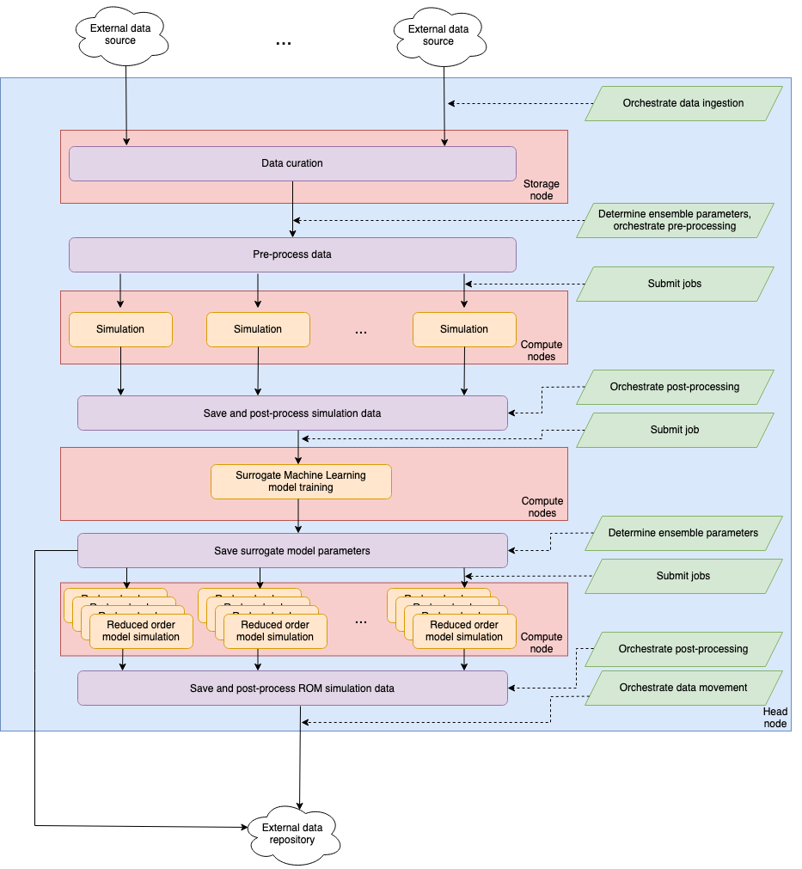
The goal of this workflow is to use the output of an ensemble of simulations to train a surrogate model for some physical system. This surrogate model is then used to run a much larger ensemble of simulations of a reduced order model (ROM). The results of the ROM ensemble and the parameters of the surrogate model and saved to an external data repository.

A flow chart for this workflow is given above. The workflow is orchestrated by executing a single script on the system’s head node. The tasks performed by this script are shown in green parallelograms, with the blue background denoting that these are executed on the head node. These tasks orchestrate components of the workflow, which are separate scripts or programs (and denoted with rounded rectangles). These are either executed on the head node (denoted purple on a blue background) or executed on a compute node (denoted orange on a red background).

